Photons, Neutral Rhythms, and Earth: Calculations & Effects

Prepared for: Gabino Casanova • Date: September 29, 2025

# Abstract

Photons—quanta of the electromagnetic field—carry energy and momentum and stream across our solar system at the speed of light. This document summarizes a practical, calculation-first view of photons for engineering concepts such as navigation, shielding, and warp‑tunnel ideas. We outline how to estimate photon counts, energy, momentum, and radiation pressure; how to translate wavelengths to photon energy; and how to connect those numbers to Earth’s ‘neutral rhythm’: daily, seasonal, and solar‑cycle variations that modulate photon flux in predictable ways. We close with worked examples (solar constant, visible‑band photon counts, radiation pressure) and a discussion of how additional photon sources—from natural variability to engineered beams—could nudge atmospheric, ionospheric, and spacecraft‑environment conditions without violating known physics.

# 1) Photon Essentials (Quick Primer)

• Speed: All photons propagate at c ≈ 2.9979×10⁸ m/s in vacuum.

• Energy: E = h·f = h·c/λ. Example at 550 nm (green): E ≈ 3.6×10⁻¹⁹ J per photon.

• Momentum: p = E/c. Photons exert radiation pressure when absorbed/reflected.

• Flux & Irradiance: Irradiance I (W/m²) is power per area. Photon rate Φ = I / E (photons/m²/s) at a given wavelength or band‑average energy.

• Radiation Pressure: For perfect absorption, P_absorb = I/c. For perfect reflection, P_reflect = 2I/c.

# 2) Earth’s 'Neutral Rhythm' in Photons

By ‘neutral rhythm,’ we refer to regular, baseline variations in the photon environment that do not depend on local technology: (a) the diurnal cycle (day–night), (b) seasons (solar zenith geometry), and (c) the ~11‑year solar activity cycle. These rhythms are predictable and largely cancel over long averages, hence ‘neutral’—yet at short timescales they produce real, measurable patterns in photon flux, air heating, and ionospheric ionization.

• Diurnal: Surface photon flux rises after sunrise, peaks near local noon, and falls toward sunset. Clouds and aerosols modulate this strongly.

• Seasonal: Axial tilt changes the Sun’s maximum elevation and day length, shifting average daily photon totals with latitude.

• Solar Cycle (~11 years): Top‑of‑atmosphere irradiance varies by ~0.1%. This subtly affects upper‑atmosphere heating and ionization.

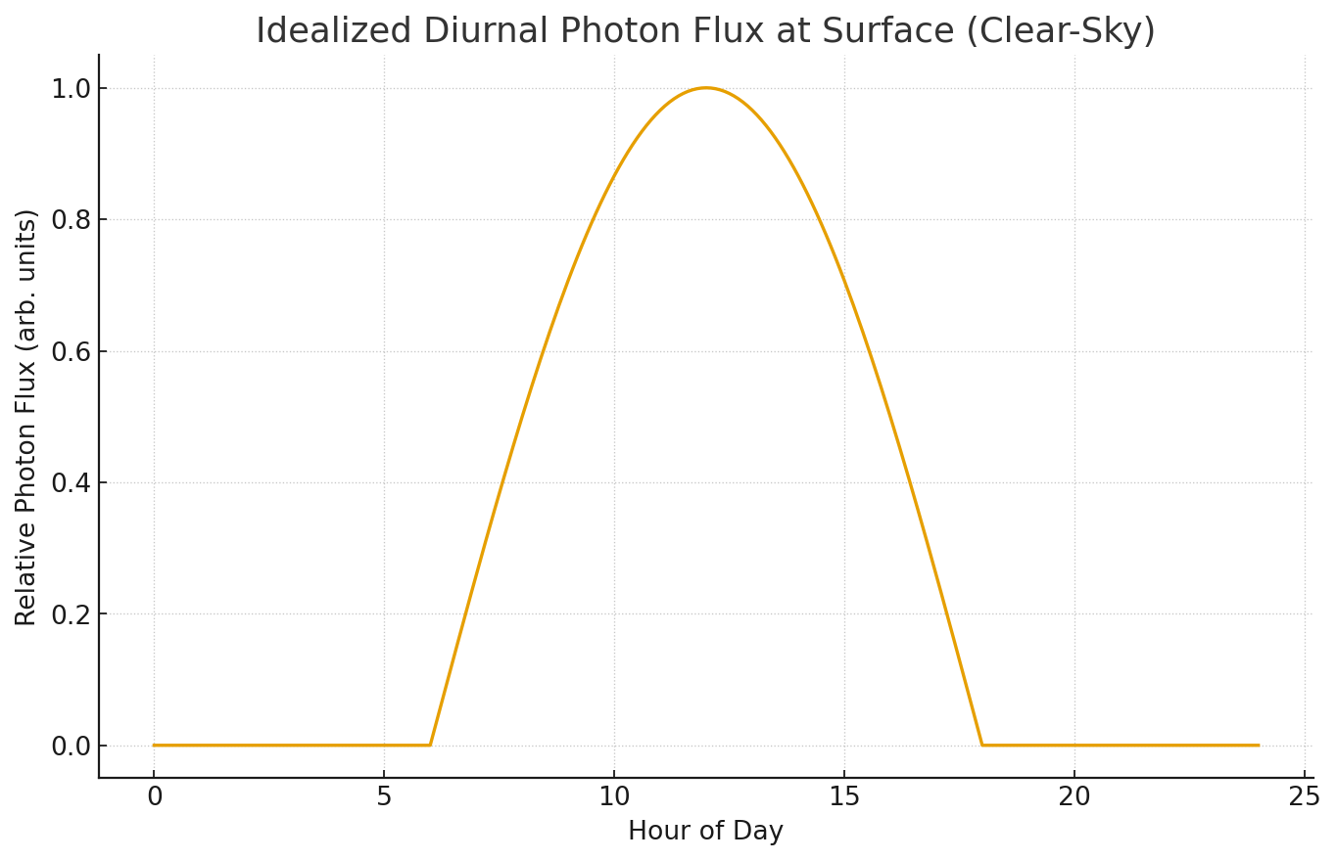

Figure 1. Idealized daylight cycle of relative surface photon flux. Real curves depend on latitude, season, clouds, and aerosols.

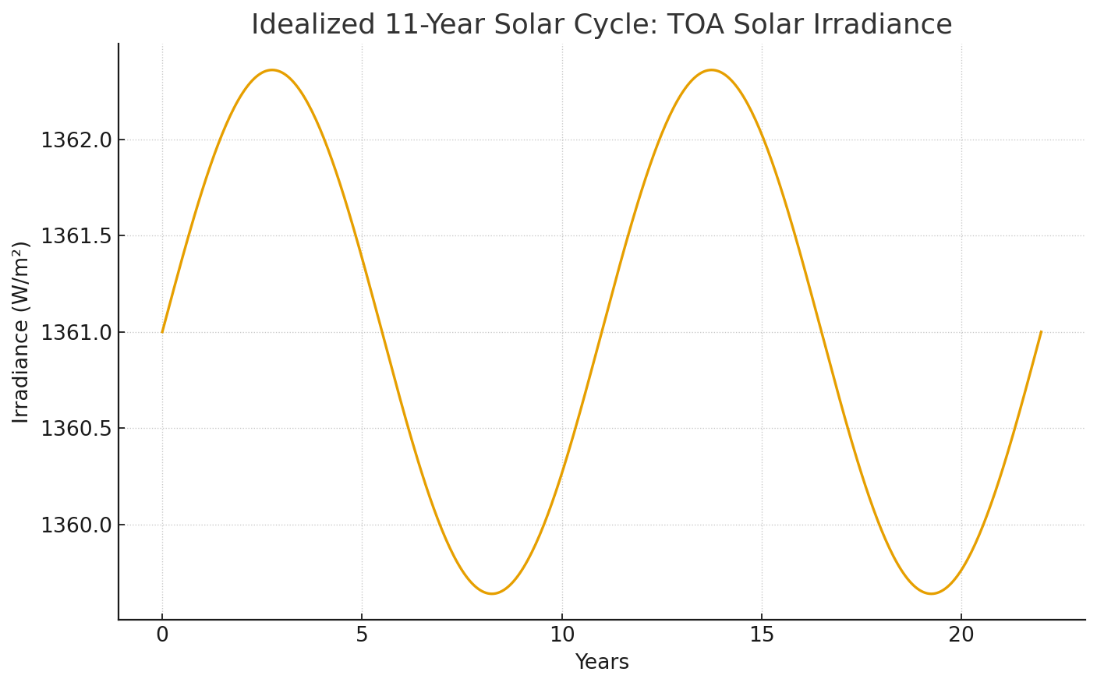

Figure 2. Simplified 11‑year variation (~±0.1%) in top‑of‑atmosphere solar irradiance (≈1361 W/m² baseline).

# 3) How We Calculate Photon Numbers & Effects

To connect physical intuition to numbers, we start with irradiance I (W/m²) and convert to photon counts per second per square meter using a representative photon energy. When needed, we integrate across a spectrum (e.g., AM1.5 solar spectrum), but a single‑wavelength estimate provides a useful order‑of‑magnitude.

• Step A — Choose/measure irradiance I. Example: top‑of‑atmosphere solar I_TOA ≈ 1361 W/m²; clear‑sky noon at sea level often 700–1000 W/m².

• Step B — Choose wavelength λ (or band). Example: λ = 550 nm → E ≈ 3.6×10⁻¹⁹ J.

• Step C — Photon rate Φ = I / E. Example at 1000 W/m²: Φ ≈ 1000 / (3.6×10⁻¹⁹) ≈ 2.8×10²¹ photons·m⁻²·s⁻¹.

• Step D — Momentum flux & pressure. For absorption: P = I/c; for reflection: 2I/c.

• Step E — Force on an area A: F = P·A. Acceleration a = F/m for mass m. In vacuum with large mirrors, even tiny pressures produce measurable Δv over long durations.

# 4) Worked Numbers (Back‑of‑Envelope)

• Example 1 — Photon Count at 550 nm: For I = 1361 W/m², E_ph ≈ 3.61×10⁻¹⁹ J → Φ ≈ 3.77×10²¹ photons·m⁻²·s⁻¹.

• Example 2 — Radiation Pressure (Absorption): P_absorb = I/c ≈ 1361 / 2.998×10⁸ ≈ 4.54×10⁻⁶ Pa (4.54 µPa).

• Example 3 — Radiation Pressure (Reflection): P_reflect ≈ 9.08 µPa. On A = 10 m², F ≈ 9.08×10⁻⁶ × 10 ≈ 9.1×10⁻⁵ N.

• Example 4 — Idealized Sail Acceleration: For a 10‑kg probe with a 10‑m² perfectly reflecting sail at I = 1361 W/m², a ≈ 9.1×10⁻⁶ m/s². Over 1 day, Δv ≈ a·t ≈ 0.79 m/s; over 100 days, ~79 m/s (ignoring attitude, distance from Sun, degradation).

# 5) 'Additional Photons' and Earth: What Changes, What Doesn’t

‘Additional photons’ can come from (i) natural variability (solar flares, active regions), (ii) human sources (city light, lasers, communications), or (iii) reflective/absorptive surface changes (albedo engineering). Here is what they realistically do:  
• Upper Atmosphere/Ionosphere: Enhanced EUV/X‑ray during solar activity increases ionization, altering radio propagation and satellite drag.  
• Weather/Climate Scale: Small, short‑lived changes in visible/near‑IR flux have minimal direct weather impact; long‑term, broad‑band changes (or aerosol/cloud shifts) matter more.  
• Surface/Near‑Earth Tech: High‑power beams can produce local heating, ablation, or momentum transfer (deflection) on small particles—relevant to the Arrow Shield concept.  
• Biological/Material Exposure: UV doses and thermal loads scale with photon energy and flux; protection and materials testing should respect relevant safety standards.

# 6) Relating to Navigation, Shielding, and 'Warp' Ideas

In speculative tunnel‑geometry or field‑shaping concepts, photons remain faithful to local physics: they move at c in vacuum and deliver momentum p = E/c. Two practical cross‑overs emerge:  
1) Sensing & Timing: Photons (lasers, pulsars, starlight) define timing links and navigation references—crucial for any CST‑synchronized system.  
2) Environmental Control: Directed photon fields (lasers/microwaves) can clear dust via ionization/ablation and impart tiny Δv to hazards ahead of a vehicle. These effects are small per photon but accumulate with power, dwell time, and distance management.

# 7) How We 'Determine Calculation Speed'

While photon speed in vacuum is fixed at c, ‘calculation speed’ refers to how quickly we can estimate relevant photon metrics for design decisions. A practical workflow is:  
• Measure/assume irradiance I at the location/condition of interest (TOA, surface clear‑sky, cloudy, laser power on target).  
• Pick representative wavelengths or integrate over a spectrum to get energy per photon E.  
• Compute photon rate Φ = I/E and, when needed, spectral photon flux (photons·m⁻²·s⁻¹·nm⁻¹).  
• Convert I to pressure P = I/c (absorb) or 2I/c (reflect) and then to forces and accelerations on surfaces.  
• Iterate quickly with software to evaluate scenarios (diurnal/seasonal geometry, pointing, albedo, beam power).

# 8) Safety and Measurement Notes

• Eye/skin safety limits for lasers and UV vary by wavelength and exposure; follow laser‑safety standards (ANSI Z136 series, IEC 60825).  
• Use calibrated radiometers/photodiodes for I; spectrometers for band‑resolved measurements; pyranometers for broadband solar.  
• For momentum/pressure demonstrations, optical balances or micro‑cantilevers can detect µPa‑scale forces.  
• Data logging against local time (CST), UTC, and solar geometry (solar zenith angle) helps reveal the neutral rhythms described above.

# Conclusion

Photons provide a clean bridge between theory and measurable engineering effects. With a few equations—E = h·c/λ, Φ = I/E, and P = I/c—we can estimate how many photons arrive, how much momentum they deliver, and how those numbers ride atop Earth’s neutral rhythms (day, season, solar cycle). These foundations support practical navigation/timing links and controlled photon‑based environmental management (e.g., Arrow Shield concepts), while keeping our interpretations anchored to established physics.

# References (Concise)

• Solar Constant ≈ 1361 W/m² (Kopp & Lean; satellite composites).

• Einstein (1905): Photoelectric / light quanta foundations.

• Radiative transfer & solar spectrum: ASTM G-173 (AM1.5) for terrestrial reference.

• Laser radiation pressure demonstrations in precision metrology and optical trapping.